W300D(V3.0)-If the IPTV could not work
Product line: ADSL Question category: trouble shooting
- Before you do the IPTV settings in your Tenda W300D, please make sure that you could get Internet access in your computer which is connected to the LAN port of your Tenda W300D. And the IPTV is connected to the default LAN port (ITV port). Check whether the led light which corresponding to the ITV is on.
- Please make sure that the IPTV function has already been enabled.
  - Connect your computer to the LAN port of the W300D. Open a web browser and type 192.168.1.1 in the address bar, and then hit Enter.

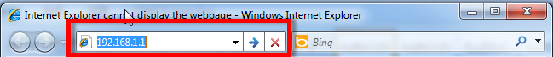

  - Click on advanced Settings.

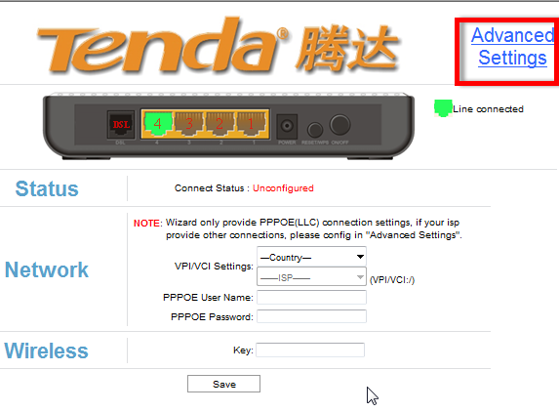

  - Click on ATM Interface and then click on Add.

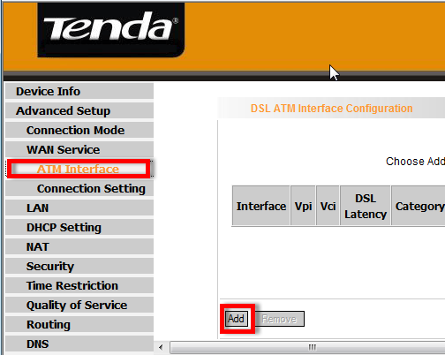

  - Type in the correct VPI/VCI value and choose the correct DSL Link Type.
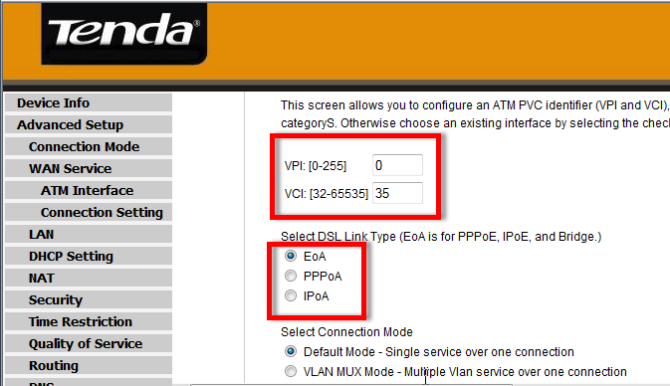

  - Click on Connection Setting and click on Add.
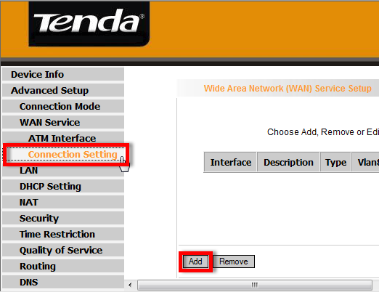
  - Make sure that you have selected the correct WAN service type.
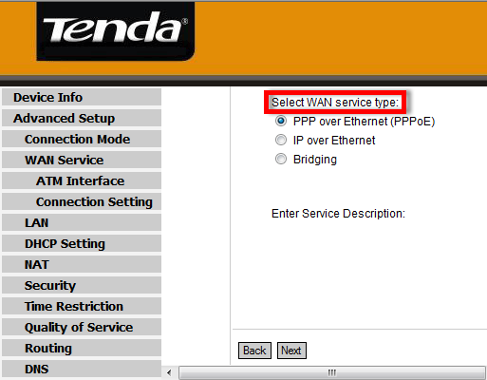

  - Finish the settings and get your IPTV worked.

- If your connection type is PPPoE, please make sure that after typing in the PPPoE user name and password, you`ve checked the Bridge PPPoE Frames Between WAN and Local ports.
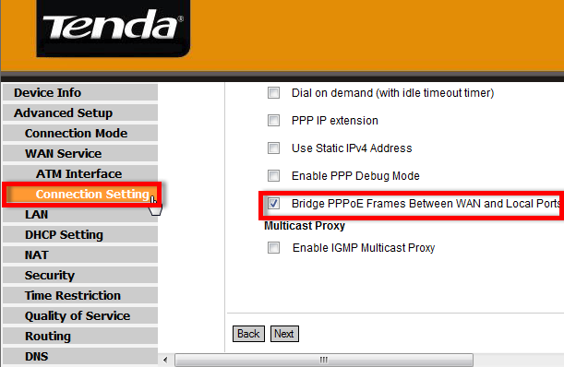

- If your Connection Type is Dynamic IP, please disable the DHCP server.
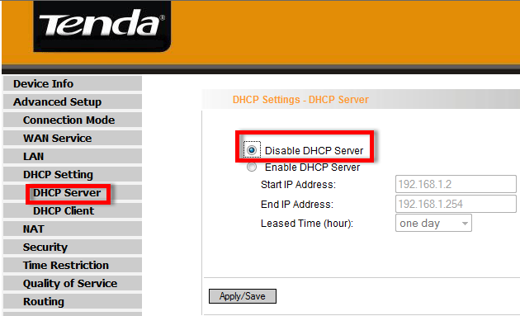

- If your connection type is IPOE or IPOA, please make sure that you have enabled the IGMP Multicast.
